**Data Science for Engineers**

**Lab Report 8**

**Hafiz Ahmad**

**19l-1316**

**Section-7A**

**Exploratory Data Analysis**

**INTRODUCTION:**

Explanatory visualizations are used to communicate the results of your analyses. Well-designed explanatory visualizations convey the results of your analyses in a clear and concise manner. The goal of explanatory data visualization is to communicate findings and inspire action.Exploratory Data Analysis (EDA) is an approach to analyzing data. It's where the researcher takes a bird's eye view of the data and tries to make some sense of it. It's often the first step in data analysis, implemented before any formal statistical techniques are applied. Exploratory data analysis (EDA) is an approach you can easily leverage to summarize the key attributes of your data. Besides, it's a methodology that employs graphs and charts to squeeze answers out of your raw data. This strategy uses data visualization designs and statistics to extract insights into data.

**TYPES OF EXPLORATORY DATA ANALYSIS:**  
  
Univariate Non-graphical. Multivariate Non-graphical. Univariate graphical. Multivariate graphical.

**OBJECTIVES:**

• To get familiarized with Exploratory Data Analysis



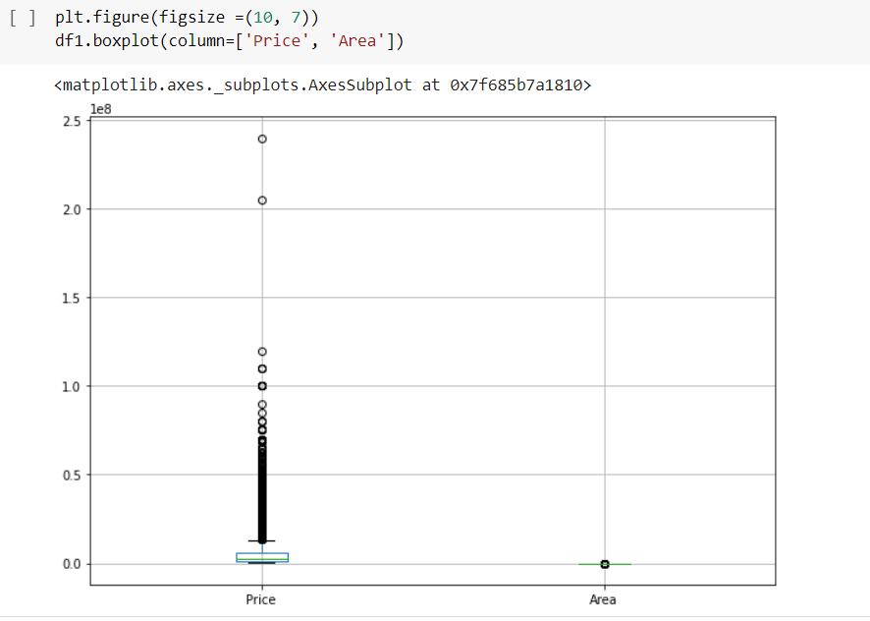

**Application:**

Exploratory data analysis can help detect obvious errors, identify outliers in datasets, understand relationships, unearth important factors, find patterns within data, and provide new insights. Exploratory Data Analysis (EDA) is a data analysis technique that can be used to visually represent the knowledge embedded deep in the given data set. The application of this technique can be used in medical data processing for the betterment of the offered services of healthcare providers.

**Issues:**

we never find any issue regarding this lab.

**Conclusion:**

Finally, we can say that exploratory data analysis is a proven methodology that can help Data Scientists to make sense of complex datasets. By using visualizations and other methods, you can uncover patterns and relationships that you might not have found otherwise.